Creating a New SharePoint Site for SpecterX Storage

Step 1- Start Creation

[Method #1]
- Go your organization’s SharePoint (https://<myorgname>.sharepoint.com/)
- Looking for the ‘Create site’ button on the top-right of the SharePoint site.

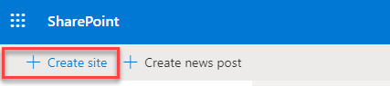

[Method #2] (only in case Method #1 was not applicable)
If the ‘Create site’ and ‘Create news post’ button don’t appear, try the following:
- Go to https://admin.microsoft.com/AdminPortal/
  - Login with customers tenant aip-service user
- Click ‘Show all’
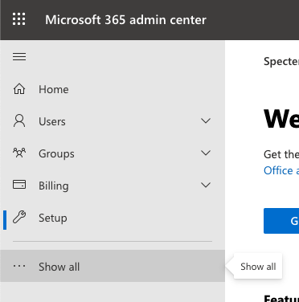
- From the new list that opened, click ‘SharePoint’
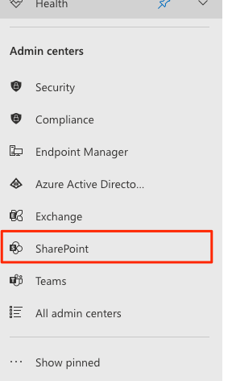
- On the left-side menu, click ‘Sites’ and then ‘Active sites’
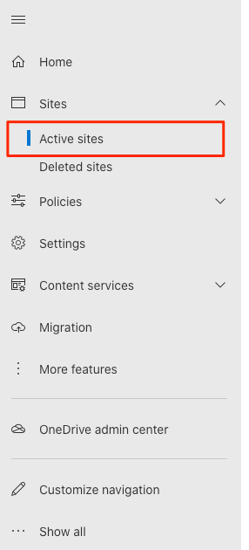
- On the new page the loaded, below the big ‘Active sites’ title, find and click the ‘Create’ option
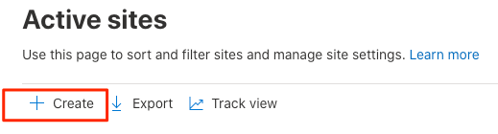

Step 2 - Configure Created Site
- Select “Team site”
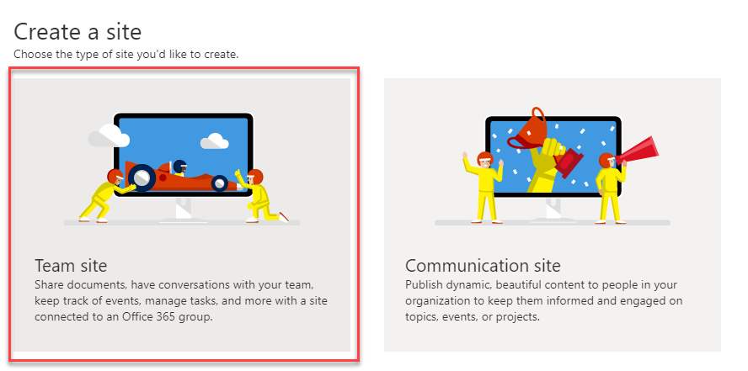
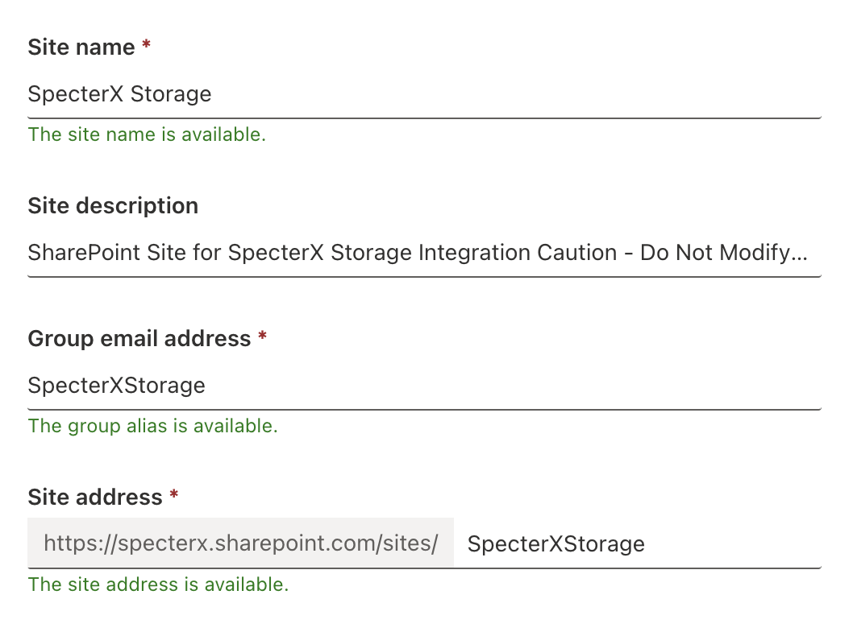
- Setup the site using those parameters:
  - Site name: “SpecterX Storage”
  - Language: English
  - Privacy settings: “Private”
  - Group owner (if requested): Your email address
  - Description (copy and paste the following):
SharePoint Site for SpecterX Storage Integration
Caution - Do Not Modify or Delete This Site: Please do not delete or alter the status of this SharePoint site even if it appears to be inactive. It is integrated with SpecterX for enhanced data security operations. Any deletion or unauthorized changes could disrupt essential data workflows and security protocols.

Purpose of This Site: This site serves as a secure repository for files managed by SpecterX, ensuring that our data sharing processes are both secure and compliant with your organizational policies.
Need Assistance or Have Questions? For any inquiries about the SpecterX integration or if you require support, please reach out to us at support@specterx.com.

- Click “Next”
- If a “Who do you want to add?” step is shown, just click “Finish”. You can change this setting later.
- Congratulations, the site has been successfully created!
- Copy the url from the browser’s address bar and save it as ‘Site URL’.
It should be something like: orgname.sharepoint.com/sites/SpecterXStorage
You will use this Site URL in the next steps as a baseline for other pages you’ll visit.
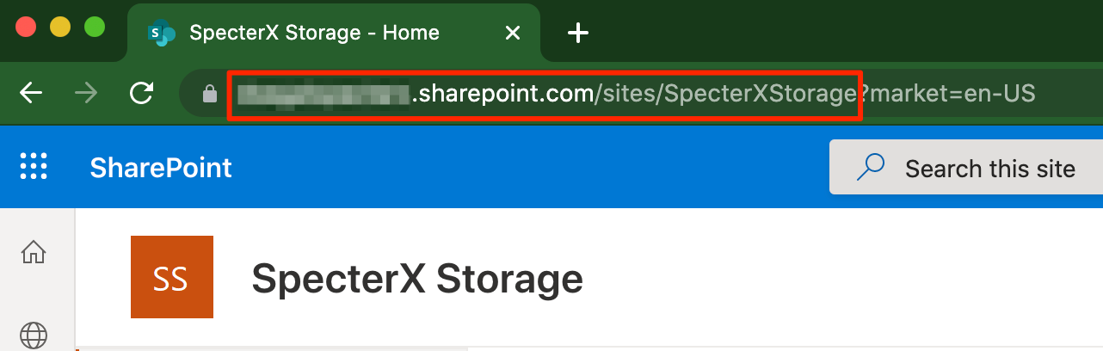

In the next segment, we’ll give the SpecterX platform permission to save files on this site.

Step 3 - Enable App Permissions on the SharePoint Site
For a new SharePoint subscription, ‘Grant App Permission’ is disabled by default.
This is a feature that’s required on the next steps, so let’s make sure it’s turned on.

There are 2 methods for allowing Grant App Permissions, the first method is via GUI and the second option is via PowerShell CLI.

Method #1 - Enabling App Permissions on your SharePoint via SharePoint GUI
- In your browser, navigate to - [Site URL]/_layouts/15/ManageFeatures.aspx
- In the opened web page find "Workflows can use app permissions"
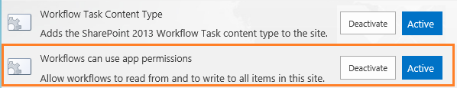
- Make sure it is Active. If not, activate it.

Method #2 - Enabling App Permissions on your SharePoint via PowerShell CLI
Note: This step is required only if you can’t find the ‘Activate’ button through the previous method.

To allow making the operation through CLI, you’ll need to disable default security in you Azure tenant. Follow these steps: https://docs.microsoft.com/en-us/azure/active-directory/fundamentals/concept-fundamentals-security-defaults

To enable this feature, we need to connect to SharePoint using Windows PowerShell and run:
Install-Module -Name Microsoft.Online.SharePoint.PowerShell
$adminUPN="<the full email address of a SharePoint administrator account>"
$orgName="<name of your Office 365 organization>"
$userCredential = Get-Credential -UserName $adminUPN -Message "Type the password."
Connect-SPOService -Url https://$orgName-admin.sharepoint.com -Credential $userCredential
set-spotenant -DisableCustomAppAuthentication $false

Step 4 - Disable Offline Sync
Not all default features are required when setting up a SharePoint site, let’s disable some.
- Navigate to [Site URL]/_layouts/15/srchvis.aspx
- Change the following settings:
  - “Allow this site to appear in search results?” - Set to “No”
  - “Allow items from this site to be downloaded to offline clients” - Set to “No”

Step 5 - Register an Application in the Azure Portal
Now that SharePoint is ready to give permissions, we’ll create an application in Azure with permissions to read and write files to the site.

While performing the following steps, keep note of these four values:
- Site URL - The site created on the previous step
- Application ID - The ID of the application we’ll create in the next steps
- Certificate Thumbprint - Will be generated after uploading the app’s certificate
- Tenant ID - A constant throughout your SharePoint tenant

To create the application in Azure, follow these steps:
- Login to the Microsoft Azure Portal as an Admin
- Go to App Registrations and Register a new application.
- Complete the following details:
Name | SpecterX SharePoint Connector
Supported account types | Accounts in this organizational directory only (Single tenant)
Redirect URI | Leave empty
- Click ‘Register’ at the bottom of the page to register the new application.
- Go to App Registrations again, find the newly created application and click on it.
If you can see it, click the tag ‘All applications’ and write ‘SpecterX SharePoint Connector’ in the search box that says “Start typing a display name or application (client) ID to filter these results”
- You should now see a page like this:
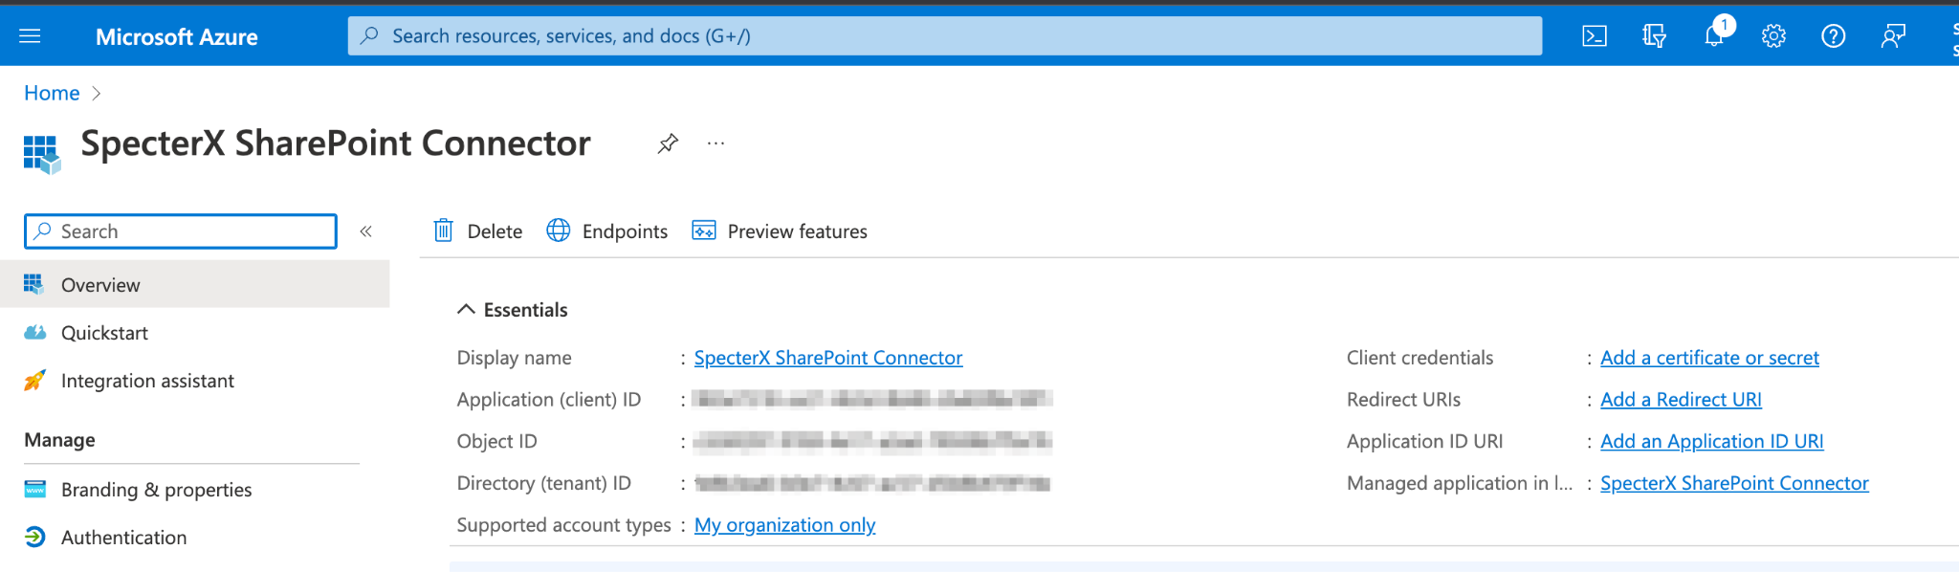
- Copy the value for ‘Application (client) ID’ and set aside.
- Copy the value for ‘Directory (tenant) ID’ and set aside.

Step 6 - Upload SpecterX Certificate
- In the application, go to the ‘Certificates & secrets’ page. If you can’t find it, type ‘Certificates & secrets’ in the Search bar below the app’s name.
- Choose the ‘Certificates’ tab.
- Click ‘Upload certificate’ and upload the cert file shared with you by SpecterX.
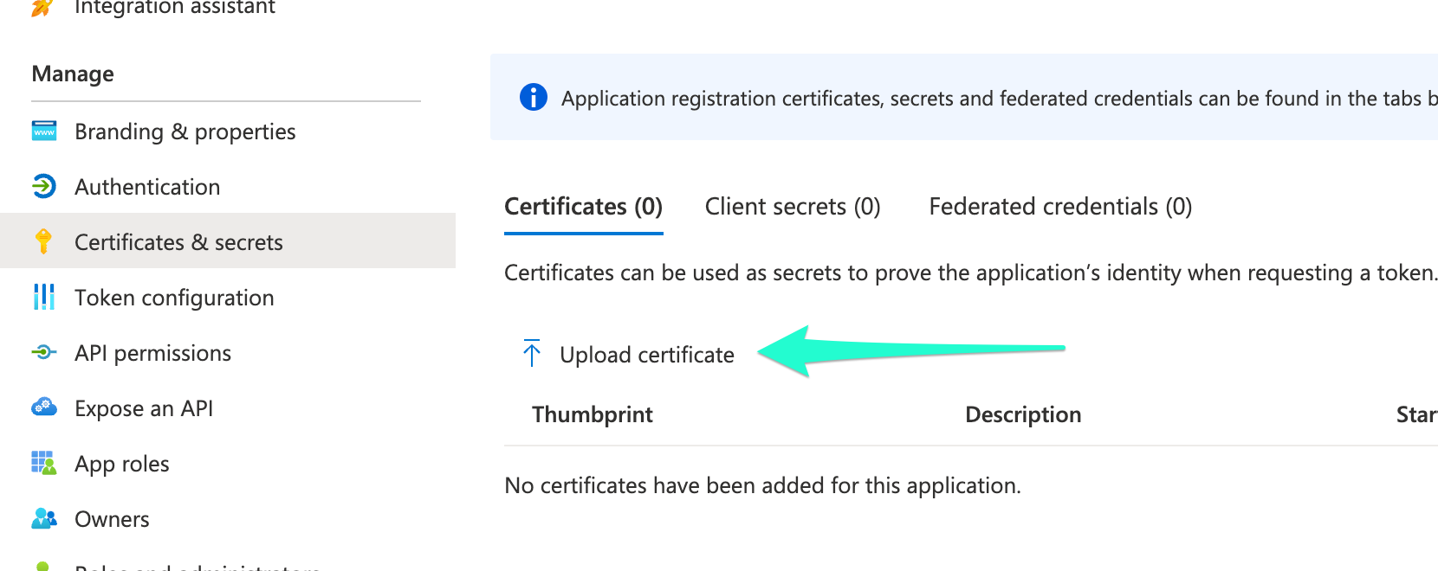
- Click ‘Add’ at the bottom-right of the screen.
- The new certificate should appear in the table now.
Copy the ‘Thumbprint’ value and set aside.
- Go to ‘API Permissions’ and click ‘Add a permission’
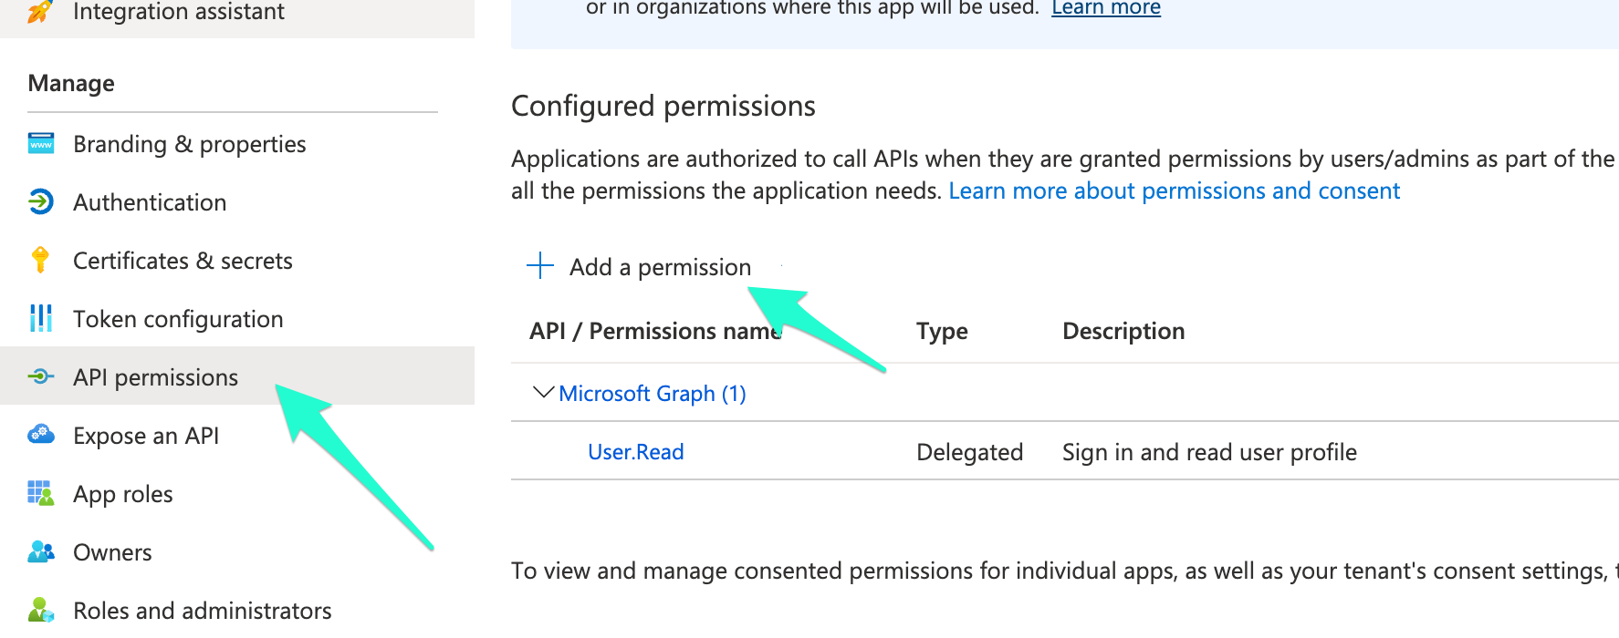
- From the menu that opened, choose ‘SharePoint’, and then select ‘Application permissions’.
- Tick the checkbox for ‘Sites.Selected’ (Access selected site collections).
This will grant the application you created access only to specific sites.
Later in this manual we’ll specify the exact site that we’ve created earlier.
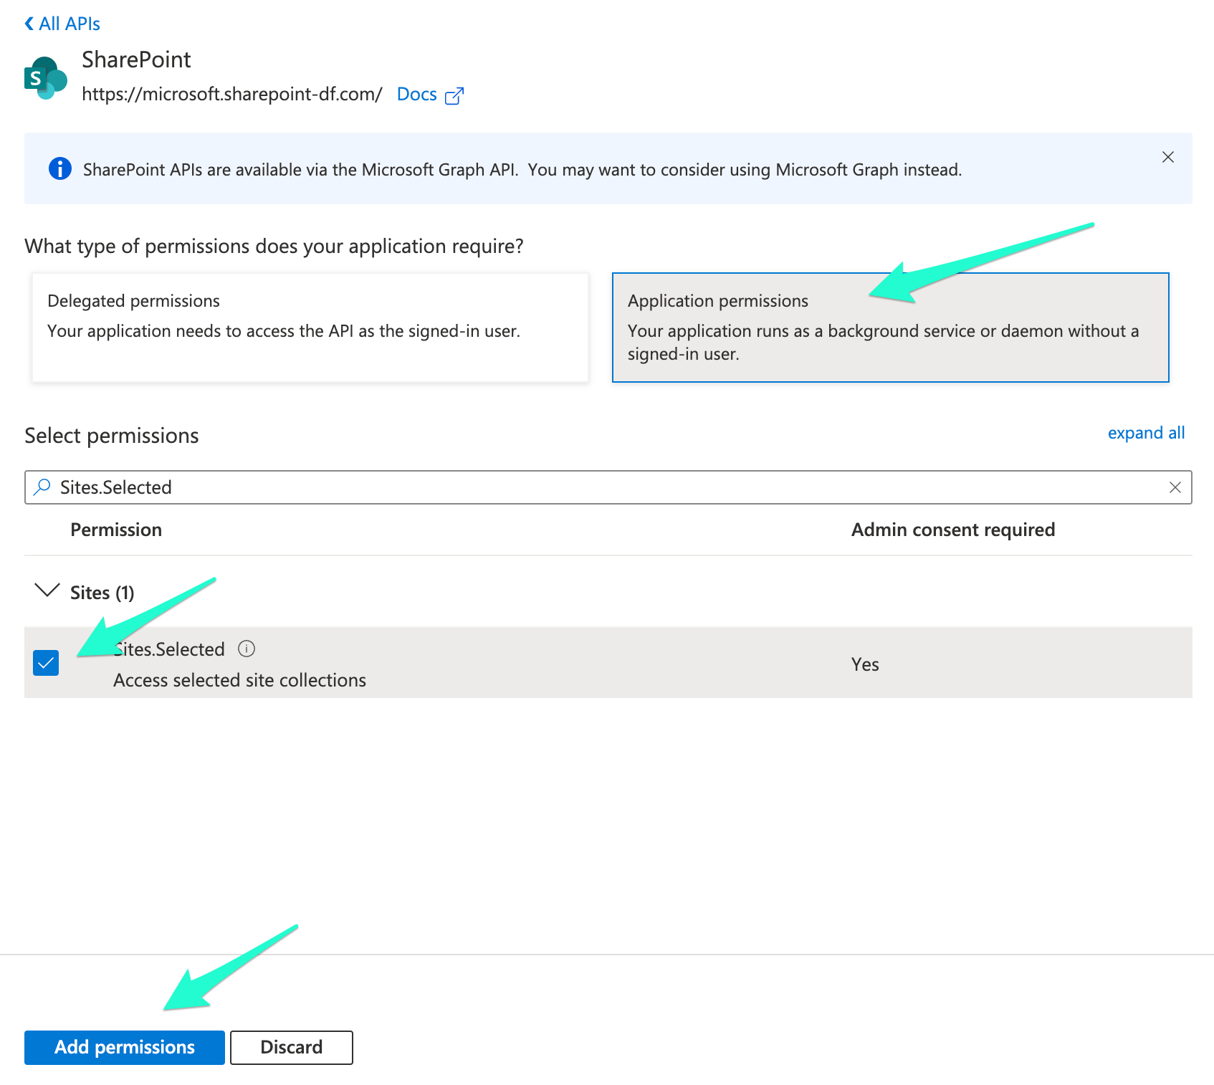
- Click ‘Add permissions’ to add the selected permission.
- Click ‘Grant admin consent’. This button should only be clicked by an admin user who has reviewed the permissions being granted and is authorized to approve them.
- The app is now set up. Next, we’ll give it Site permissions.

Step 7 - Grant the Application permissions to the created Site
- In your browser, navigate to - [Site URL]/_layouts/15/appinv.aspx
- In the App ID field, paste in the Client ID of your Entra ID application you copied earlier
- Click Lookup.
- Fill out or confirm the app details
- Title: A friendly name for the app.
- App Domain: Often you can put your organization’s domain or the domain associated with the app.
- Redirect URI: leave empty.
- Enter the permission XML to request “FullControl” on the site
<AppPermissionRequests> <AppPermissionRequest Scope="http://sharepoint/content/sitecollection" Right="FullControl" /> </AppPermissionRequests>

Note:
- Scope="http://sharepoint/content/sitecollection" indicates that the permission will apply to the entire site collection where you’re running the AppInv page, and will not affect other site collections in your tenant.
- Right="FullControl" grants the highest possible permission on that scope.
- Confirm and trust - Click the Create button at the bottom. You’ll see a permission consent prompt (the “Do you trust?” dialog). Confirm that you want to grant this application the requested permissions by clicking Trust It.

Step 8 - Submit to SpecterX
- Finally, log in with and Admin user to SpecterX web application in https://{your-site}.specterx.com/settings
- Fill in ‘Site URL’, ‘Client Id’ (Application ID), and ‘Realm ID’ (Tenant ID) in the SharePoint section and click ‘Save’.
- That’s it! SpecterX is now configured to save you sensitive materials on your own organizational storage

